--
Academic Year: 2024-25 Semester: V Class / Branch: TE IT
Subject: DevOPs Lab (DL)
Subject Lab In-charge: Prof. Sujata Oak
EXPERIMENT NO. 08
Aim: To demonstrate container lifecycle using various docker commands.
Theory:
Docker is a platform that allows us to package our applications into deployable executables called containers, with all its necessary OS libraries and dependencies.
A container is a process in OS. A process is an instance of a computer program that is being executed. But container processes are different. Container processes are fully-functional environments, and they have more isolation from the OS than the processes in OS.Just like processes, containers have different states throughout their lifecycle.
There are mainly five states that a container can be in during its lifecycle -
- Created state
- Running state
- Paused state/ Unpaused state
- Stopped state
- Killed/Deleted state

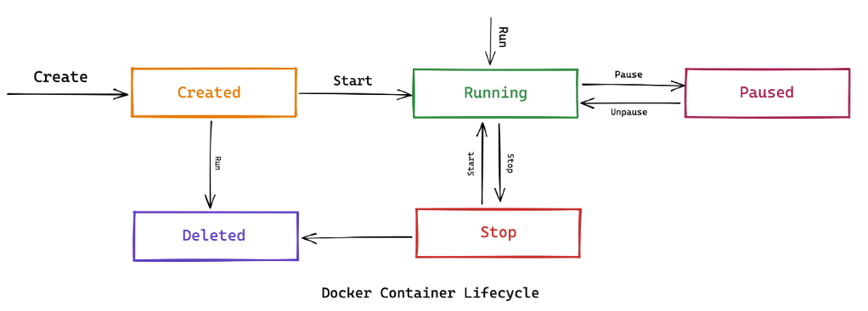
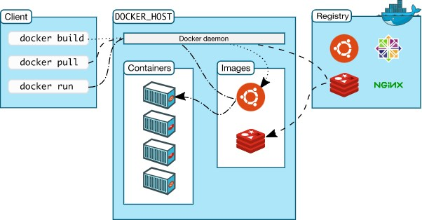

Fig. Architectural overview of Docker

Step1: Install Docker using the convenience script
Take sudo privileges.

# curl -fsSL https://get.docker.com -o get-docker.sh

# sudo sh get-docker.sh

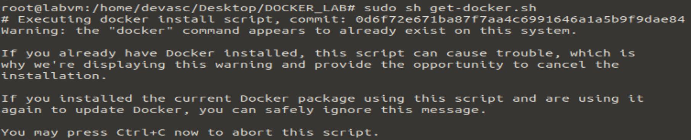

Step2: To verify docker is installed or not:

# docker version

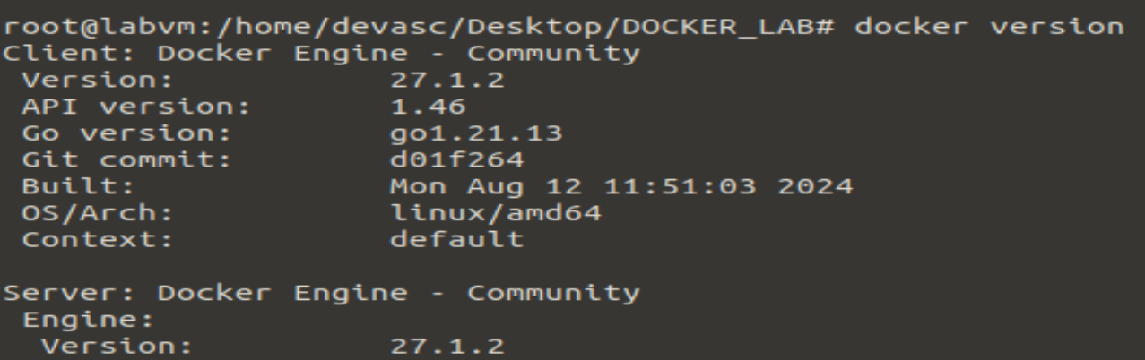

DOCKER COMMANDS:

1] How you login into your Docker Hub Account from CLI?
#docker login

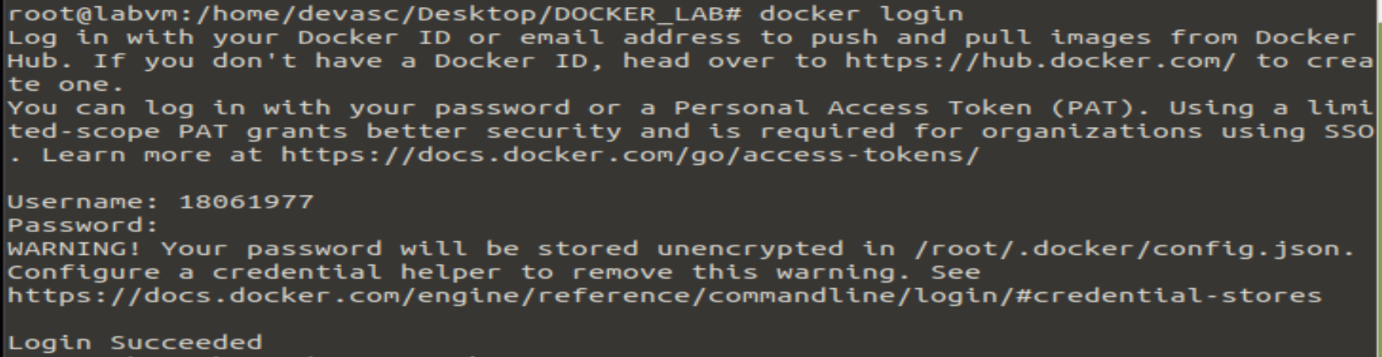

2] #docker run : It helps you to run a container on top of your docker engine, but the ingredients that it needs is image name.

#docker run hello-world
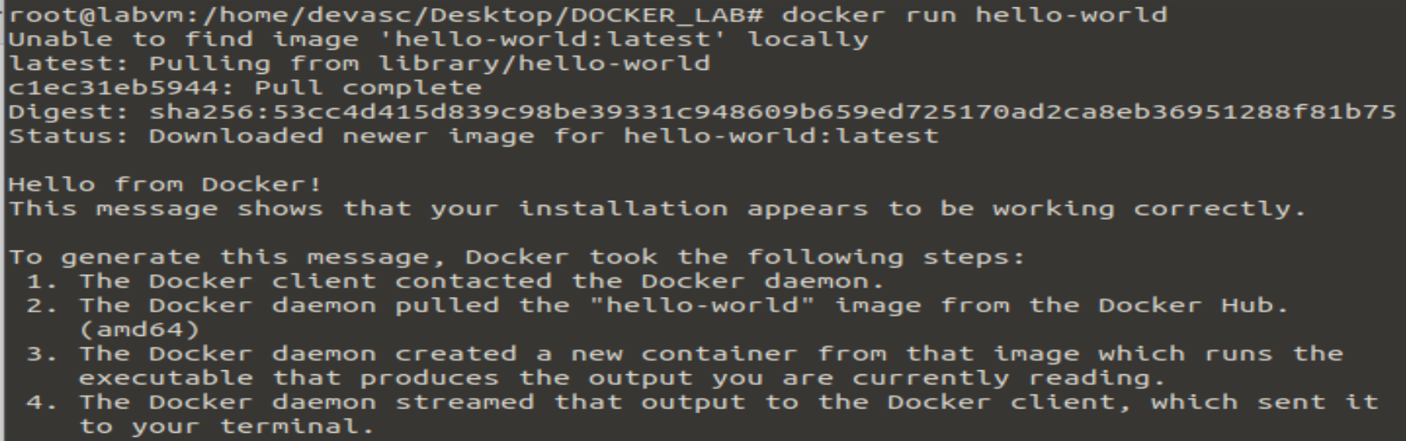

The command used to access the running container Is:
You Can run a ubuntu container with following command:
#docker run -it ubuntu bash

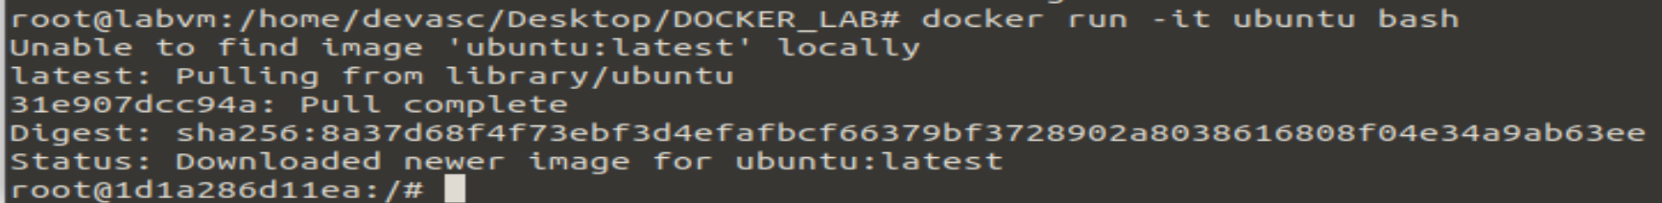

3] How to see the image that I just downloaded whether it is available on my machine or not?

docker images: This command is used to show all the pulled images from docker

# docker images

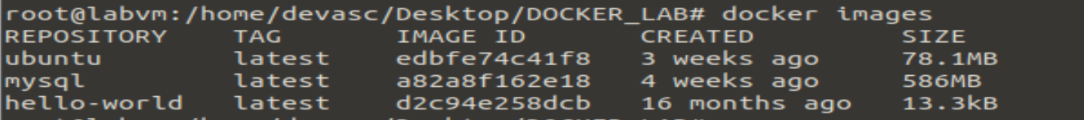

Try to launch a docker image for testing purpose, you can find the images in docker public repository at https://hub.docker.com

4] docker pull: This command is used to pull images from the docker repository(hub.docker.com)
Usage: docker pull <image name>

#docker pull mysql
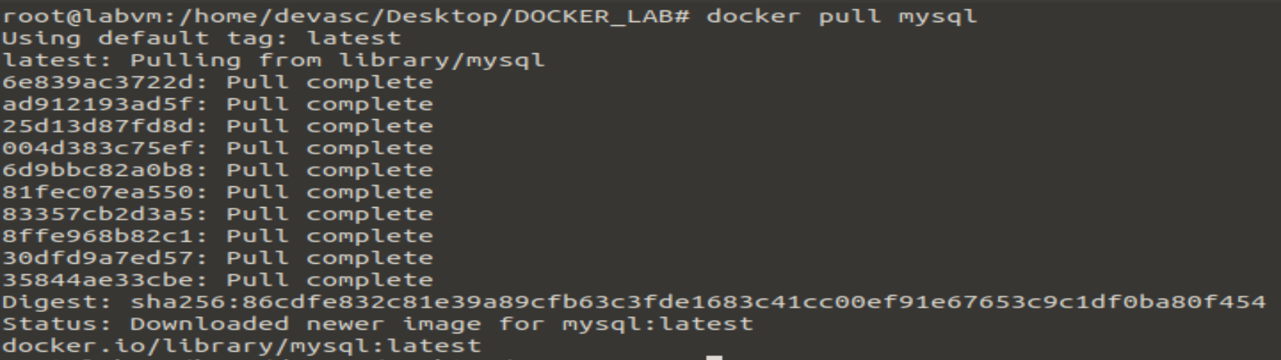

5] docker ps : This command lists the running containers on my system

6] docker ps -a : This command list all containers running or exited from the system.

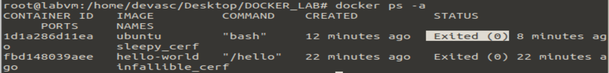

Now to get the container running : #docker run -it ubuntu bash

In New terminal: docker ps -a

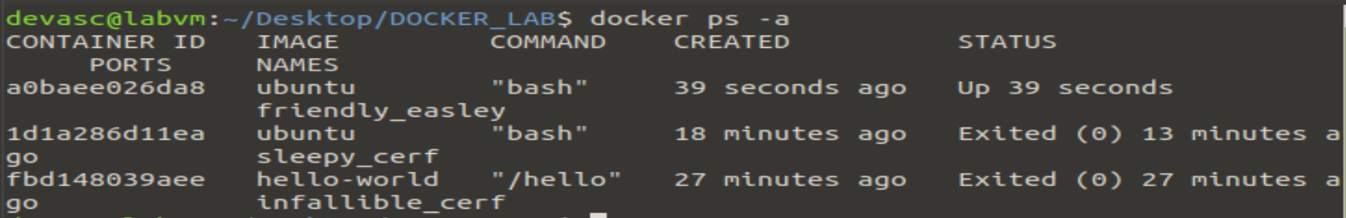

In First Terminal: ls

You wil see the lists of directories available in ubuntu container

Now get exit from ubuntu container

In New terminal: docker ps -a
So You see the container has exited 3 minutes ago.

NOTE: Every container created has a unique container id. That is, from a single image multiple containers can be created. Also, every container will be independent of itself, will be isolated from other container

NOTE: If you don’t provide name to your container , the docker-engine gives fancy name to your container.

7] docker exec: This command is used to executes the container.

Usage: docker exec -it <container id> bash

8] To delete the container: #docker rm <container-name/container-id>

9] To delete the image: #docker rmi <image-name/image-id>

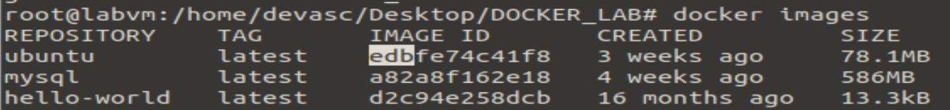

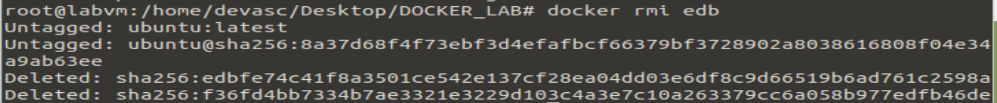

10] Commands related to containers:

docker start <container-id> : Start the stop container
docker stop <container-id> : Stop the running container
docker pause <container-id> : Pause the processes in running container
docker kill <container id> : Kill the container.

Task 2: HOW TO SETUP AND CONFIGURE MYSQL DATABASE INSIDE DOCKER CONTAINER?

MySQL is the single most popular relational database tool.
MySQL is popular because it is simple yet powerful. Here are its best features:

- Relational: follows the relational model and uses SQL to manage databases.
- Open-source (GNU license): the community loves it. Companies love it.
- Scalable: can handle applications from small-sized to enterprise-level.
- Secure: offers user authentication, access management, and encryption.
- High-performance: known for its speed and efficiency in handling complex queries and large volumes of data.
- Replication and backup: it has options for data replication and backup, allowing for disaster recovery strategies.

Step 1: To pull the image of mysql from docker hub

#docker pull mysql:latest



EXPLANATION: The code is a Docker command, not SQL.
• It's used to download the latest version of the MySQL Docker image.
• "docker pull" is a command that tells Docker to download an image from Docker Hub.
• "mysql:latest" specifies the image to download.
• "mysql" is the name of the image and "latest" is the tag.

Step 2: List the mysql images

#docker images

Docker images are blueprints for building containers. Just like a blueprint allows you to build a house, a Docker image contains all the necessary instructions and components to create a running instance of an application or service.

STEP 3: Running and Managing a MySQL Server Container

Now, let’s create our first container from the mysql image. Here is the command we will use:

$ docker run --name test-mysql -e MYSQL_ROOT_PASSWORD=strong_password -d mysql

EXPLANATION:

- run: creates a new container or starts an existing one
- --name CONTAINER_NAME: gives the container a name. The name should be readable and short. In our case, the name is test-mysql.
- -e ENV_VARIABLE=value: the -e tag creates an environment variable that will be accessible within the container. It is crucial to set MYSQL_ROOT_PASSWORD so that we can run SQL commands later from the container. Make sure to store your strong password somewhere safe (not your brain).
- -d: short for detached, the -d tag makes the container run in the background. If you remove this tag, the command will keep printing logs until the container stops.
- image_name: the final argument is the image name the container will be built from. In this case, our image is mysql.

If the command returns a long string of gibberish (the container ID), it means the container has started. You can check its status with docker ps:

In New Terminal:

Step 4: To access the terminal inside your container, you can use the following command:

$ docker exec -it container_name bash

This will launch a bash session.

Connecting to the MySQL Server Container Locally :

All MySQL containers launch a MySQL server that includes everything to create and manage databases using SQL. To connect to the server, containers also come with a MySQL client that lets us run SQL queries. The client is just a fancy name for the mysql terminal command. Let’s use it inside test-mysql’s terminal:

- Open the bash terminal of test-mysql:

$ docker exec -it test-mysql bash

- Connect to the client as a root user:

We are using the -u tag to specify the username (root) and adding the -p tag to enter the password when prompted.

$ mysql -u root -p
Enter password: ...
mysql>

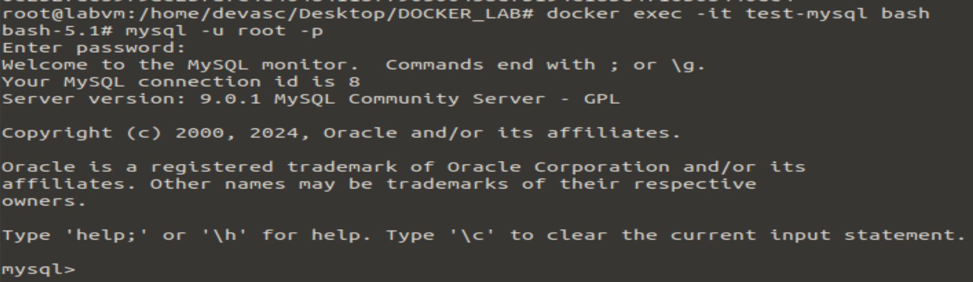

mysql> SELECT ‘hello-world!!!’;

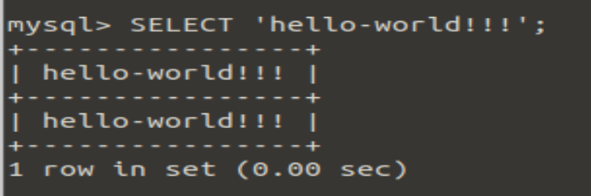

mysql> show databases;

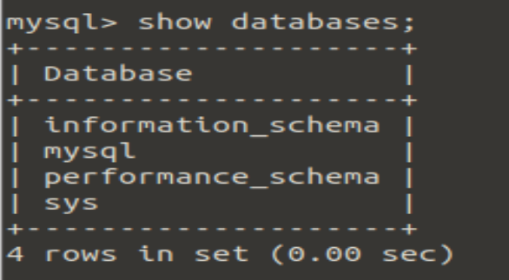

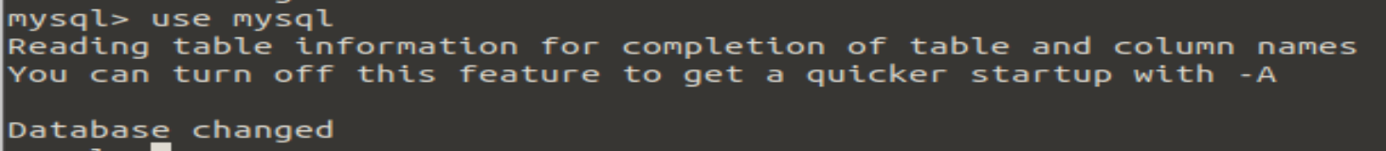

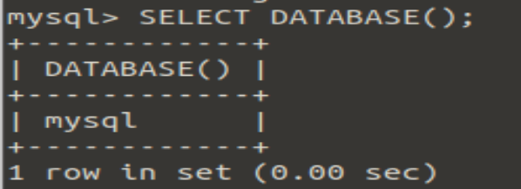

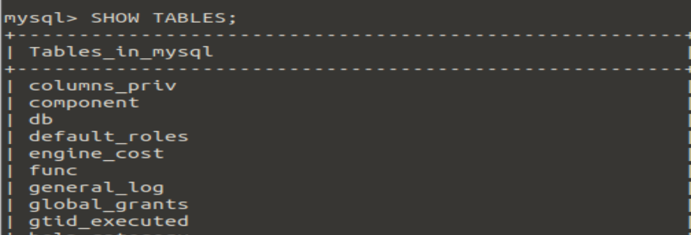

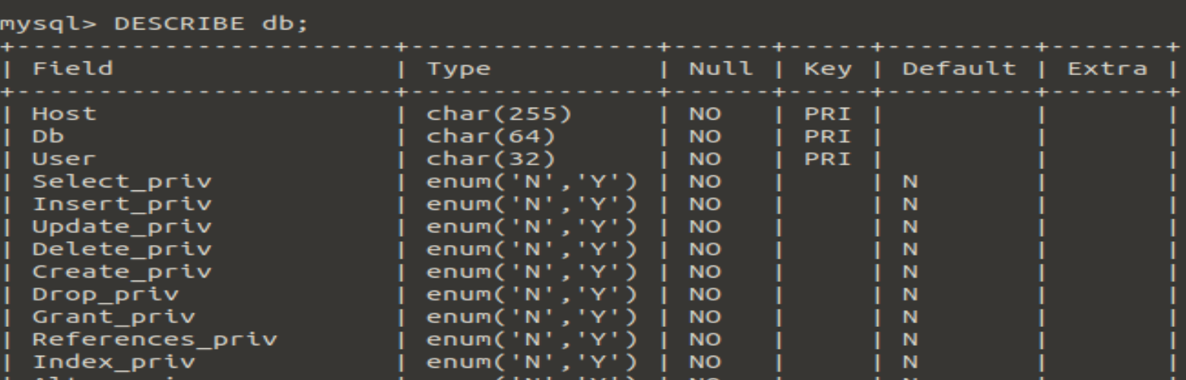

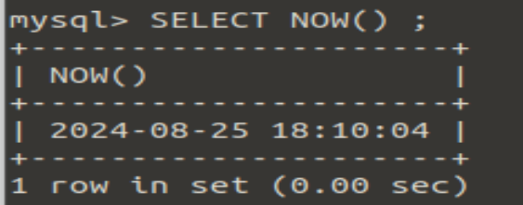
Conclusion: In this experiments student have learnt how to deal with containerization technology using various docker commands.

https://www.datacamp.com/tutorial/set-up-and-configure-mysql-in-docker
https://www.geeksforgeeks.org/mysql-common-mysql-queries/
https://docs.docker.com/get-started/docker-concepts/the-basics/what-is-a-container/

